Applied Machine Learning Assignment
Luke Cardona, Luca Alfino, and Luca D’Ascari

https://github.com/LucaKingu/Applied-Machine-Learning--ICS5110--Assignment

ABSTRACT
This project examines the classification of road traffic accident severity using supervised machine learning techniques applied to a mixed dataset of unstructured text and structured contextual features. Police press releases and local news articles were pre-processed and enriched with temporal, weather, and categorical variables, followed by an extensive exploratory data analysis (EDA) that motivated a refined focus on multiclass severity prediction. Accident severity labels were constructed through a rule-based approach derived from normalized textual indicators of harm. Three modelling approaches the Ridge-regularised linear regression, Support Vector Machines (SVM), and Random Forest were implemented and evaluated under a shared, stratified train–test split. Model performance was assessed using class-balanced metrics, with Macro F1 as the primary evaluation criterion due to target imbalance. Results show that Random Forest achieves the strongest overall performance and class separability, while Ridge-based linear regression offers a competitive and more interpretable alternative. SVM demonstrates weaker performance on minority classes. The findings emphasize the importance of textual features in severity prediction and highlight trade-offs between predictive performance, interpretability, and computational efficiency in imbalanced multiclass settings.
INDEX TERMS Linear Regression, Support Vector Machines, Random Forest Trees

- INTRODUCTION

Vehicle accidents in Malta are of a high concern as they are not only deadly but are often a cause of high traffic congestion. In this project, we explore the severity of accidents given an extensive dataset.

Hence, while this project initially set out to evaluate various machine learning models, the Exploratory Data Analysis (EDA) revealed a compelling primary objective: the classification of accident severity. Consequently, the research focus was refined to prioritize this specific challenge. Each team member independently explored a distinct methodology to optimize performance for the severity label. While this prioritized focus narrowed the scope of broader research questions, it allowed for a deeper and more rigorous comparative analysis of the selected models under a single, high-value objective
Related Work

Linear Regression

Linear regression is a supervised learning technique that models the relationship between input features and a target variable using a linear function and bias, with parameters estimated by minimizing prediction error through the Least Squares method [1]. Although effective for numerical prediction, linear regression performs poorly in high-dimensional settings such as text classification, where the number of features can exceed the number of samples, leading to singular matrices, non-unique solutions, and increased overfitting risk [1, 2]. To address the requirement for numerical input in textual tasks, linear regression is often combined with TF-IDF, which converts unstructured text into high-dimensional numerical vectors representing word importance; these vectors serve as predictor variables, allowing the model to learn the influence of individual words in tasks such as sentiment analysis on film reviews or Twitter posts [1–5].

Support Vector Machine

Support Vector Machines (SVMs) are a set of supervised learning methods used for classification, regression and outlier detection [6]. Past literature investigates whether SVM models can effectively predict car crash injury severity [7]. This study evaluates the effectiveness of Support Vector Machines (SVM) compared to traditional Ordered Probit (OP) models in predicting crash injury severity at freeway diverge areas in Florida. Utilizing a dataset of 326 locations and an 80/20 training-test split, the research demonstrates that SVM provides superior predictive accuracy (48.8% vs. 44.0%), particularly for high-severity minority classes. By employing sensitivity analysis to interpret variable impacts - such as road geometry and traffic conditions - the study concludes that SVM effectively captures complex nonlinear relationships while overcoming the "black-box" limitation, making it a robust alternative for
safety analysis.
Random Forest

Random Forest is widely used as a competitive baseline for classification on structured data because bagging and random feature selection reduce variance and typically improve out-of-sample performance (Breiman, 2001) [8]. In text classification, a common and efficient representation is TF IDF, which transforms each document into a sparse vector of weighted terms and short phrases, emphasising terms that are frequent within a document but less common across the corpus (Ramos, 2003) [9]. This representation is a standard baseline because it is simple, scalable, and often competitive for topic and label prediction tasks.

However, combining TF IDF with tree ensembles introduces practical trade-offs. Sparse high-dimensional vectors can increase training time and memory usage, and they can make interpretation less stable because many correlated n-grams may encode similar meaning. In this notebook, TF IDF is therefore capped to a fixed maximum number of features and model selection is performed with stratified cross-validation to reduce sensitivity to a single train-test split.

Finally, `severity_label` is imbalanced, so accuracy alone can give an overly optimistic view if performance is driven by the majority class. Macro averaged F1 is reported because it weights each class equally, making minority class performance visible and aligning evaluation with the project requirement to assess multi-class behaviour rather than only overall correctness (Sokolova and Lapalme, 2009) [10].
Data (EDA)

The following packages were used for the data preparation python file:

• Pandas
• Collections
• Requests
• Datetime
• Sklearn

We were given two datasets
Police Press Releases
Original Dataset:
Title
Date Published
Date Modified
Content
TABLE I – Police Press Releases Dataset

Transformed Dataset:
Content
Temperature 2m* Mean
Apparent Temperature 2m Mean
Precipitation Sum
Precipitation Hours
Wind Speed 10m Max
Is Holiday
Year
Month
Day
Tag National
Tag Accident
Tag Traffic
Tag Police
Tag Transport
TABLE II – Police Press Realises Transformed Dataset

* <num>m = meters above the ground.

Local News Articles

Original Dataset:
Article ID
URL
Source Name
Source URL
Title
Subtitle
Author Name
Publish Date
Content
Top Image URL
Top Image Caption
Created At
Tags
Categories
TABLE III – Local news article original dataset

Transformed Dataset:
Content
Temperature 2m* Mean
Apparent Temperature 2m Mean
Precipitation Sum
Precipitation Hours
Wind Speed 10m Max
Is Holiday
Year
Month
Day
Tag National
Tag Accident
Tag Traffic
Tag Police
Tag Transport
TABLE IV – Local news articles transformed dataset

Distinct Transformations:
Police Press Releases:
Removed Columns:
•Date Modified
- Since Data Published is featured, this field is deemed redundant.

Merged/Divided Columns:
•Title / Content
- Since both contain unstructured related text data, they could be merged into one column called ‘Content’
•Tag National/Accident/Traffic/Police/Transport
- Since the below dataset gave us the top 5 appearances of its tags, we decided to keep them the same for this dataset. Hence, I extracted all occurrences where each tag is mentioned in either ‘titles’ or ‘content’ column.
•Published Date
- Divided into ‘Year’, ‘Month’, ‘Day’ columns for traditional ML models.

Local News Articles:
Removed Columns:
•Article ID
  - ID of the article, useless
•URL
  - URL of the article, useless
•Source Name
  - Due to an overwhelming number of articles extracted from ‘Times of Malta’, we decided to not include this.
•Source URL
  - Source of article URL, useless
•Author Name
  - One author, ‘Times of Malta’ also had most appearances, moreover we decided not to focus on author in any way for our target.
•Top Image URL
  - Image URL, useless
•Categories
  - Although this would have been helpful, it was empty for all rows of data.
- Merged/Divided Columns:
•Title / Content
  - Since both contain unstructured related text data, they could be merged into one column called ‘Content’
•Tag National/Accident/Traffic/Polie/Transport
  - Put all tag occurrences in a single list, counted frequencies of all tags, chose top 5.
•Publish Date
  - Divided into ‘Year’, ‘Month’, ‘Day’ columns for traditional ML models.

Extra data sources / Addition of Columns – Both datasets:
Date.Nager API > Get all days which are holidays in Malta. This is added as ‘Is Holiday’ column as Boolean data type.
Open.meteo API > Gather weather forecast data. This is added as the following columns:
•Temperature 2m Mean – Mean temperature at 2 meters above the ground
•Apparent Temperature 2m Mean – Apparent Mean temperature at 2 meters above the ground (What it feels like to people)
•Precipitation Sum – Total Precipitation
•Precipitation Hours – The number of hours with rain
•Wind Speed 10m Max – Wind speed at 10m above ground

Important in-code transformations for both datasets:
•Open.meteo API data was Standardized outputting Z-Score
•Tags were one-hot encoded for Boolean understanding

Finally, both datasets were merged into one final dataset: Finalized_dataset.CSV’

Important note: It was agreed that for text vectorization for the ‘Content’ column is to be done when creating each individual technique by one defined method placed at the end of the data preparation file called ‘vectFunc’. This is due to the large number of added columns created by the vectorizer function TF-IDF, which would make the finalised dataset unreadable.

TF-IDF works best with traditional models, which was the assignment brief that required a team of 3 people to focus on. It mostly works well since TF-IDF results in sparse matrices, traditional models such as SVMs are mathematically optimised to process these sparse matrices [11]. Moreover, the vectorizer was set to 1000 features due to having 432 rows of data, but 38,806 features. This should give the model enough variety to learn while keeping the model safe from overfitting. Should the accuracy prove to be low, we will increase the features accordingly. Vice versa, we will reduce the number of features if it overfits from the start. Furthermore, minimum document frequency was set to three, hence at least three documents must feature a phrase and maximum document frequency of 80%, hence the model will ignore phrases that appear in 80% of the documents. However, this could easily be changed during the project.

EDA

The ‘2_exploratory_analysis.ipynb’ and subsequently the EDA was conducted using three types of analysis on the ‘Finalized_Dataset_Unstardadized.csv’:

1. Univariate: Analysing one feature at a time
2. Bivariate: Comparing two features together
3. Multivariate: Comparing multiple features

Unstandardized data was used for the EDA to better comprehend the weather values and their relationships. The data found in ‘Finalized_Dataset_Unstardadized.csv’ is composed of four different data types and categorised accordingly;

1.Continues: ["temperature_2m_mean", "apparent_temperat-ure_mean","precipitation_sum","precipitation_hours","wind_ speed_10m_max"].
2. Discrete: ["year", "month", "day"].
3. Binary: ["is_holiday", "tag_National", "tag_Accident", "tag_Traffic", "tag_Police", "tag_Transport"].
4. Text: ["content"].
In the python file, there are some figures and results that will not be included in the report since their findings were unconclusive however, the results were left in the python file to show transparency in the method of conducting an EDA.
- Univariate Analysis
  - Continues Features
The univariate analysis was conducted by plotting the continues data (Fig.1 & Fig.2) and observing the mean, median, variance and standard deviation.
“temperature_2m_mean” and “apparent_temperature_mean-an” show similar binomial distributions likely due to the seasonal temperatures found in Malta. The apparent temperature also has higher variance due to having lower and higher peaking temperatures.
Furthermore from (Fig.1 & Fig.2), both the precipitation features are highly left skewed distributed, with high peaks close to $0$. This indicates that most of days in Malta might not experience any rainfall. The wind speed also shown in (Fig.1) has a left-skew Gaussian distribution, indicating average wind speed of $15$.
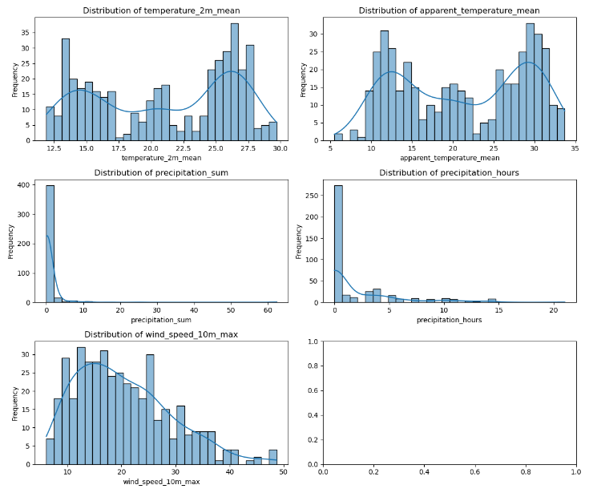
- Distribution plots of all the continues data.
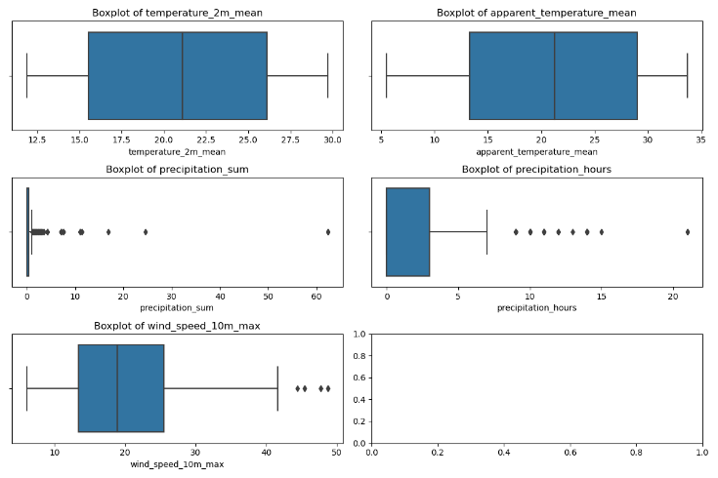
- Box plots of all the continues data.

  - Discrete Features

The "year" field almost is a constant feature as can be seen in (Fig.3). Due to the consistent nature of the field throughout the EDA, the field was dropped and will not be evaluated further.
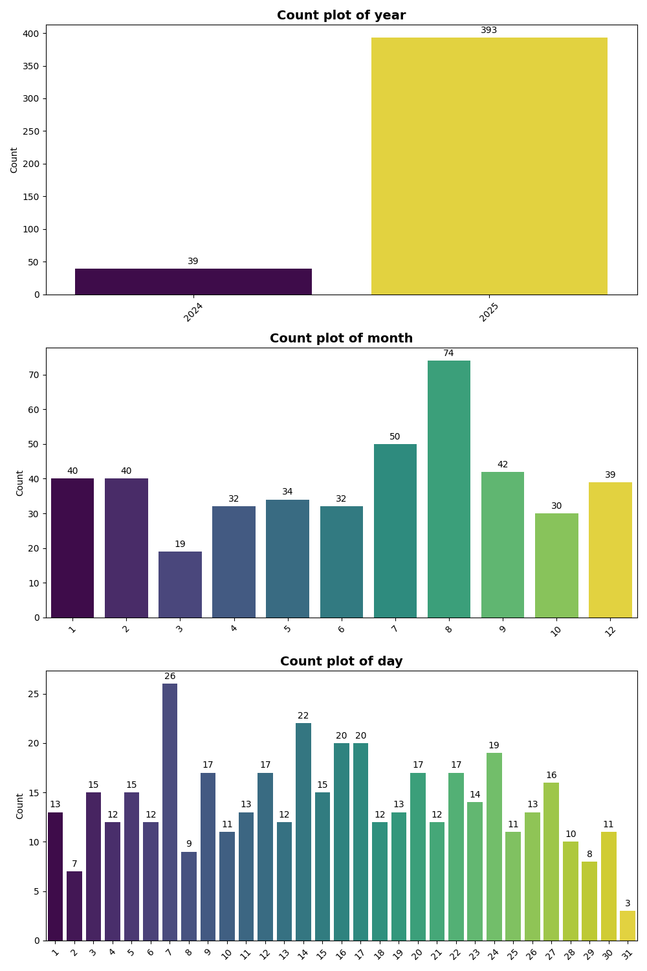
The "month" shows that there is peak of articles that were written during the busy summer periods (August to September). The "day" was originally of type discrete ranging from $1-31$. Analysing (Fig.3) is can be seen that the highest peaks were resulting about every 7 days (7th,14th,21st), this finding means that the day of the week might be relevant and was added to data to be analysed throughout the rest of EDA.
- Count plots of all the discrete data.
After the changes were implemented the "day" field showed most of the articles were being published during the Week and on Sundays with a noticeable drop on Friday’s and Saturdays (Fig.4).
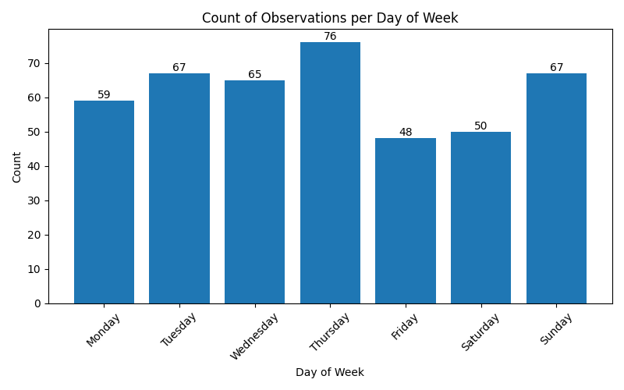
- Count plot of the “day” feature.
  - Binary Features
The binary features exhibited in (Table.1) show that the “tag_Accident”, “tag_National”, and tag_Traffic” are the three most commonly occurring binary features. This is to be expected seeing that the nature of the articles.

TABLE V
binary counts AND PERCENTAGES
Tag | Count (Articles) | Percentage (%)
“is_holdiay” | 16 |  | 3.7
“tag_National” | 320 |  | 74.0
“tag_Traffic” | 333 |  | 77.1
“tag_Accident” | 247 |  | 57.2
“tag_Police” | 180 |  | 41.7
“tag_Transport” | 32 |  | 7.4

  - Text Features
The only text feature in the dataset is the “content” column. To analyse the content, the TF-IDF scores for each word across the articles was summed. This weights where then used throughout the EDA to analyse the content of the articles. This can be seen in (Fig 6.) where the top 100 weighted words were plotted in descending order. To complete the Univariate analysis a binary count to check which unique words appeared in 40% or more of the articles was conducted (Fig 5.).
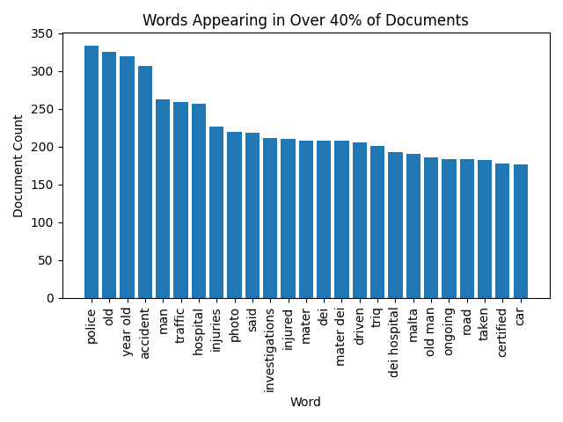
- The words that appear in more than 40% of the articles.
Analysis of the most common recurring features (Fig.5) showed that the high prevalence of words such as “police”, “accident”, “years old” algins with the structured nature of official police releases and journalistic reports on traffic incidents. A majority of articles prioritize the victim's status, frequently mentioning "Mater Dei" (the primary acute-care 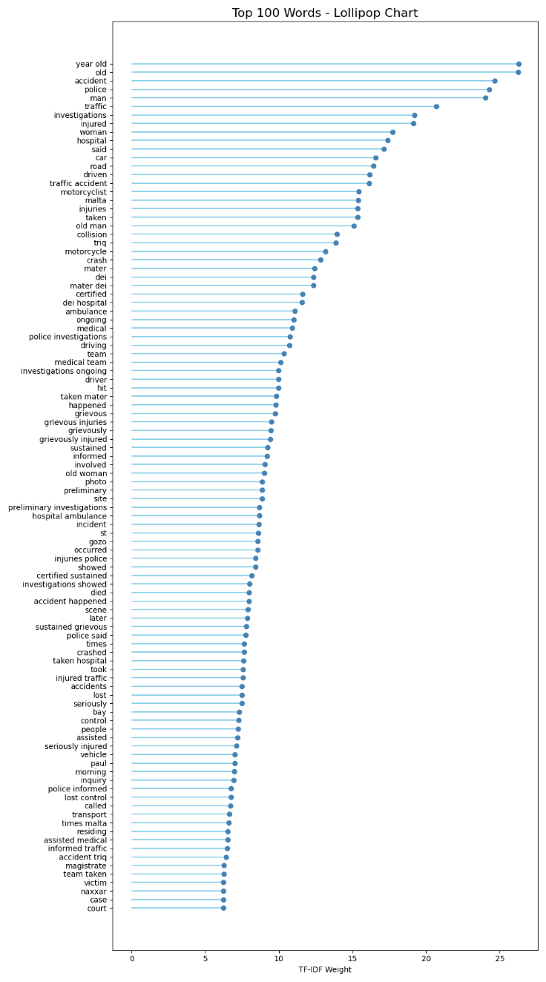
- Lollipop chart of the 100 most sum weighted words throughout all the articles.
hospital in Malta) and specific injury descriptors. The remaining frequent terms largely detail the nature of the collision and the parties involved.
The analysis of the top 100 words by TF-IDF weight revealed two primary thematic clusters (Fig.6):
1. Injury Related Features: "injured", "hosipital", "injuries", "mater dei", "ambulance", "medical", "medical team", "grievous injuries", "grievous injured", "grievously",

"injuries police", "died", "seriously injured", "assisted medical", "victim".
2. Accident & Traffic related Features: "accident", "traffic", "collision", "crash", "police investigations", "hit", "investigations ongoing", "hospital ambulance", "lost control".
- Bivariate Analysis
  - Binary Features vs Content
The top 20 words were anaylsed and from each of the tags and analysed to understand the correlation between the binary tags and the articles:
1. ‘tag_Acccident’ most of top 20 words has injury related words as well as features describing the accident.
2. ‘tag_Traffic’ had an more evenly distributed mix of injury related words and features describing the accident.
3. ‘tag_Police’ had the highest assocation with injury related words.
4. ‘tag_National’ and ‘tag_Holidays’ had a smaller assocation with injury related words and focused more on the accident details.
  - Continuous Features vs Content
The top 30 words with highest absolute correlation across any column were plotted in a correlation matrix as can be seen in (Fig 7). Some of the interesting observation that can be made from Fig 7:
1. Injury and health related words such as “medical, medical team, sustained grievous, assisted medical, grievous injuries ambulance” have a positive correlation with “precipitation_sum” but have negative correlation with “precipitation_hours” possibly indicating that short bursts of heavy rain can be one of the major causes of serious accidents.
2. Both “temperature_2m_mean” and “apparent_temperature_mean” shared similar correlations. With the most noticeable correlations being between the positive correlation with “alcohol” and “driving influence” indicating that most alcohol related accidents occur one warmer days.
3. “wind_speed_max” did not result in any strong correlations with any relevant keywords that could be used to determine the target variable.
  - Month Feature vs Day of the Week
To better grasp which combination of period of the year and the week would be most dangerous; the correlation matrix in Fig 8, was plotted.
The figure highlights how September had the highest number of articles. A spike of articles being uploaded mid-week in all weeks when compared to their respective weekends. With a significant drop in articles being published on Friday and Saturday.
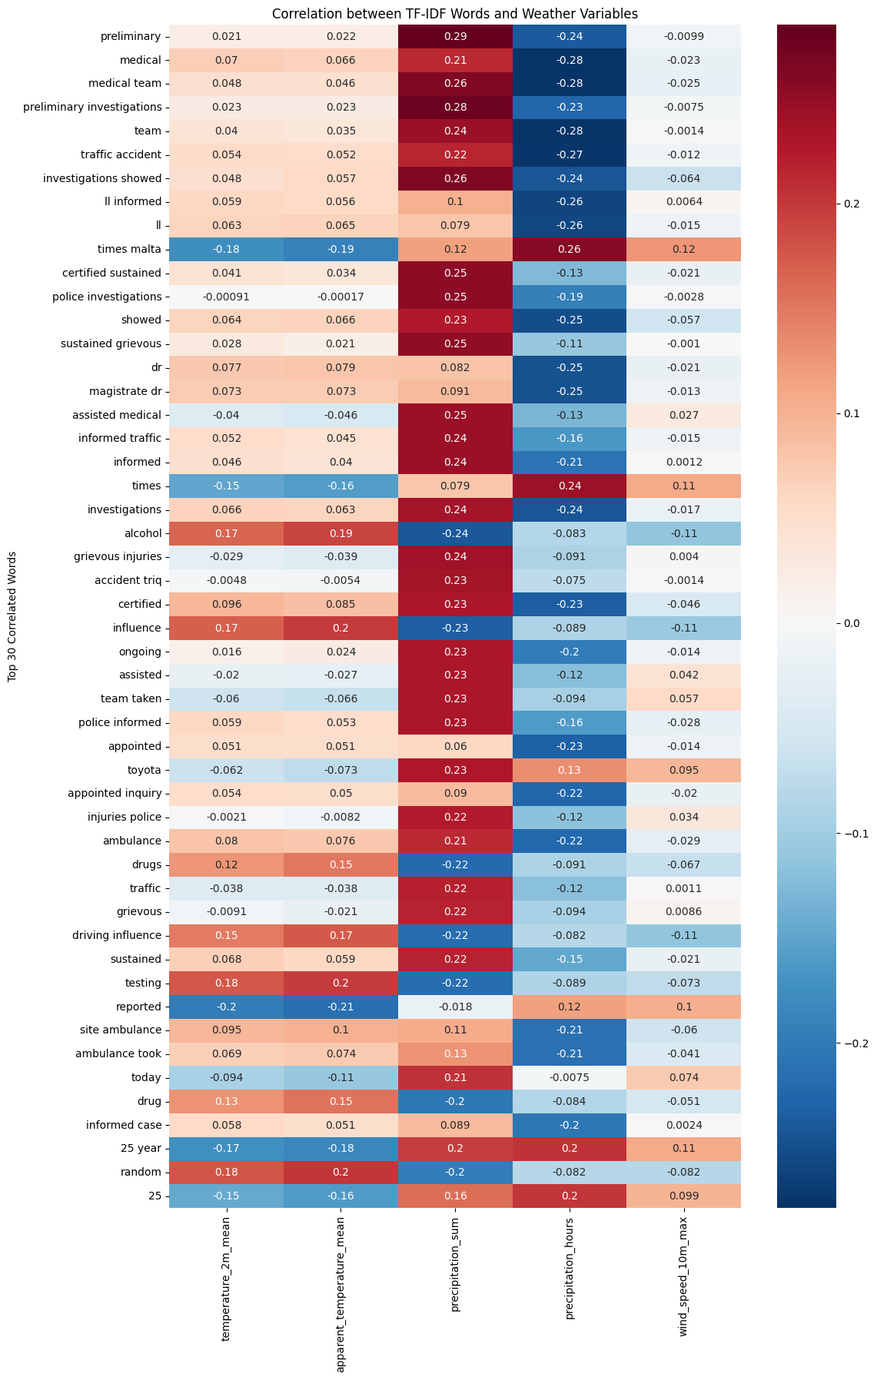
- Correlation matrix that shows the top 30 words with the highest absolute correlation.
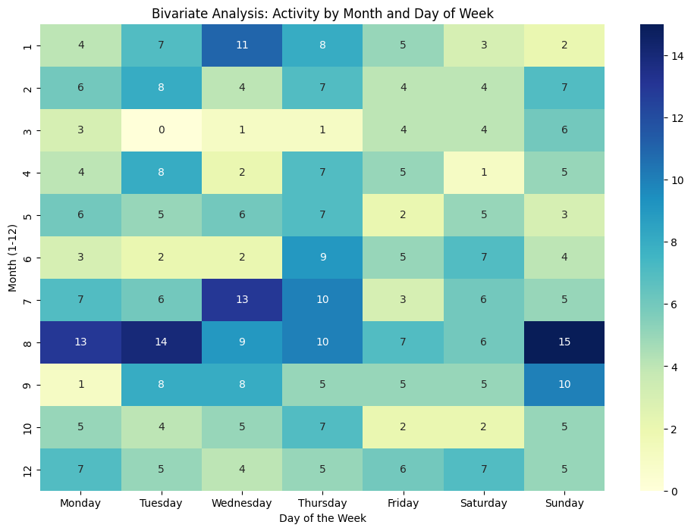
- Correlation matrix that highlights the day of week and month each article was published.
- Multivariate Analysis
Multivariate analysis was achieved by conducting a Principal Component Analysis (PCA) as can be seen in (Fig 9). PCA will take the word-level correlation features and compress them into a 2D figure. It simplifies the complex data relationships by turning many variables into just a few meaningful ones. The top 5% furthest points from the centre were labelled.
The spatial distribution of words in the PCA projection reveals distinct patterns in the article data. At the upper region of the plot, terms such as ‘medical team’, ‘preliminary investigations’, ‘ambulance’, and ‘police informed’ form a coherent grouping that reflects reports involving more severe incidents and formal emergency or medical responses. On the right-hand side, a clearly separated cluster includes words such as ‘arrested’, ‘drink’, ‘drugs’, ‘driving influence’, and ‘alcohol’, indicating a subset of articles that emphasize contributing factors related to substance use or legal consequences. On the left-hand side, the projection contains words associated with routine descriptive details, including vehicle brands (for example, Toyota and Yamaha), locations (such as regional road and Attard), and demographic references (for example, 25 year), which are commonly present across many reports. In contrast, the dense concentration of points near the centre represents generic reporting vocabulary that appears frequently across articles but does not strongly characterize any specific thematic category.
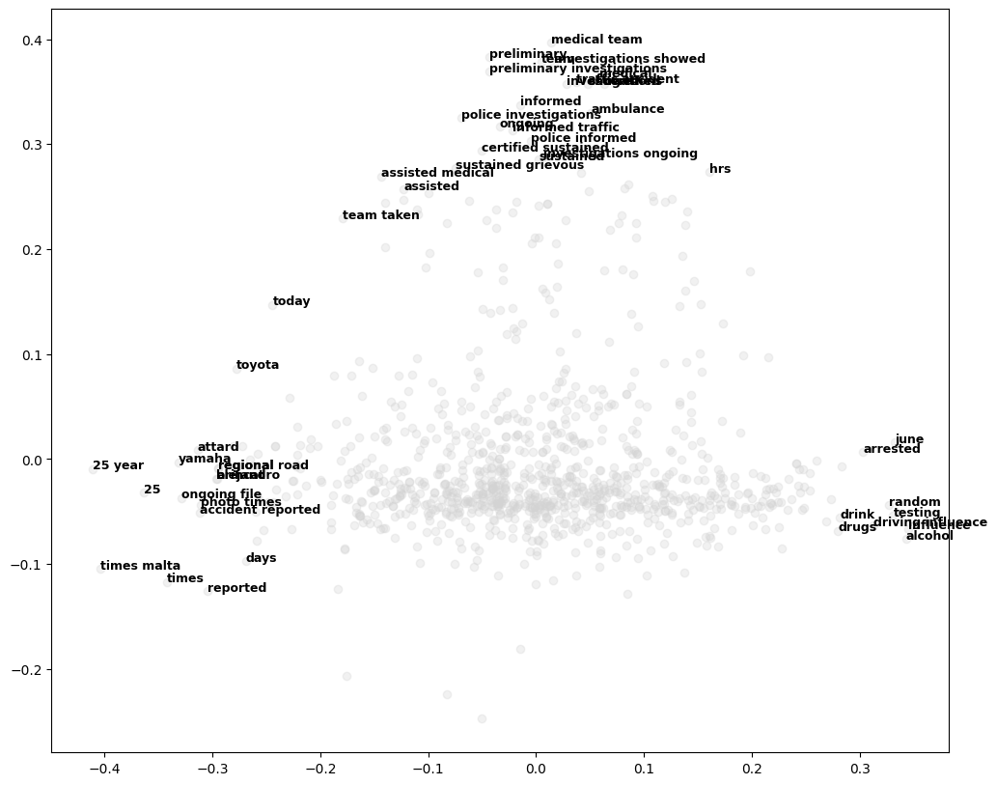
- Multivariate analysis using PCA.
Methodology
- Problem Formulation
Following the EDA, a new target variable was constructed to represent the severity of road traffic accidents. This target variable (‘severity_label’) is derived directly from the textual accident descriptions contained within the dataset and serves as the dependent variable for subsequent modelling tasks. The motivation behind this approach is to transform unstructured textual data into a structured, ordinal representation of accident severity.
To ensure linguistic consistency and reduce sparsity caused by lexical variation, the accident descriptions were first normalized using standard natural language processing (NLP) techniques. Specifically, each description was tokenized, converted to lowercase, and lemmatized to extract word roots. Lemmatization allows different grammatical forms of a word (e.g., dies, died, dead) to be mapped to a common base form, improving robustness in severity detection. Once the lemmatized word roots were obtained, accident severity was quantified using a rule-based labelling function. This function assigns an ordinal severity score based on the presence of specific keywords associated with increasing levels of harm. The severity scale ranges from 0 (no relevant accident-related terms detected) to 4 (fatal accidents). The below describes the rule-based function in pseudocode
- Assign 4 (Fatal) if any of the following terms related to death are present: ["die", "dead", "fatal", "death"]. Else go to step 2.
- Assign 3 (Serious Injury) if any of the following terms are present: [“grievous, serious”]. Else go to step 3.
- Assign 2 (Injury) if any of the following terms are present: ["injury", "hospital", "ambulance", "medical", "mater"]. Else go to step 4.
- Assign 1 (Accident) if any of the following terms are present: ["collision", "crash", "accident"]. Else go to step 5.
- Assign 0 (No Severity Detected)
Figure 10 shows the distribution of the target variable created for the ML models based on the rule-based assignment shown before.
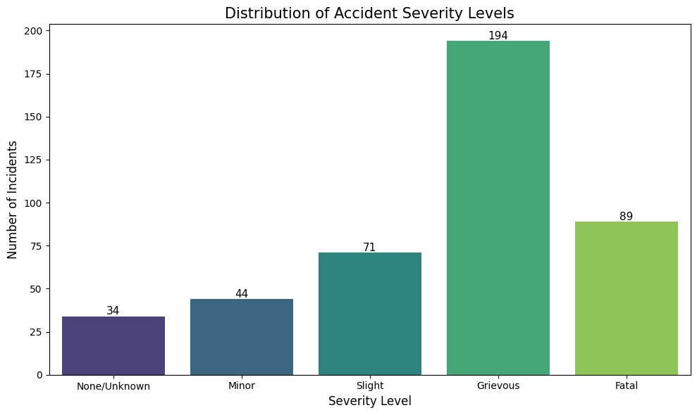
- Distribution of the target variable “Severity_label”
- Linear Regression
Linear regression is a supervised learning technique that models the relationship between input features and a target variable using a linear function of the form:
EQ (1) $f\left(x\right)=w^{T}x+b$ [1]
Where:
$w$ is the weight vector, $b$ is the bias, and $x$ represents the input features.
Its objective is to learn a weight vector and intercept that best fit the training data by minimizing prediction error, most commonly through the Least Squares method. This method reduces the squared difference between predicted values and actual targets across all training samples. While effective for many numerical prediction tasks, Linear Regression struggles in high-dimensional domains such as text classification, where the number of features often exceeds the number of training samples. In such cases, the underlying matrix can become singular, leading to non-unique solutions and a high risk of overfitting [1, 2].
Linear regression and its variants are commonly used alongside TF-IDF to enable predictive modelling and classification on textual data. Since regression models require numerical input, TF-IDF acts as the feature extraction step by transforming unstructured text into high-dimensional numerical vectors that represent the importance of words within documents [1, 2]. These TF-IDF values become the predictor variables for the linear model. The regression algorithm then learns a weight vector and intercept, multiplying each TF-IDF feature by a learned weight and combining them to produce an output. In this way, the model effectively learns how influential each word is in determining an outcome, such as linear regression being to conduct sentiment analysis on film reviews [3] or Twitter posts [4].
As mentioned in the EDA the following features were deemed unfit for Linear regression and were removed: `'precipitation_sum', 'precipitation_hours', 'is_holiday'`. Their removal was also tested, tests were conducted with and without these variables and the MSE and R² scores yielded better results when the features, where removed due to the left-skew nature of the features, which made them not fit for Linear Regression.
  - Multiple Linear Regression
Multiple Linear Regression (MLR) is a statistical modelling technique that quantifies the linear relationship between a single continuous dependent variable and two or more independent (predictor) variables. It extends the simple linear regression framework to accommodate multiple predictors by estimating a linear function of the form:
EQ (2)
$y=β_{0}+β_{1x_{1}}+β_{2}x_{2}+⋯+β_{p}x_{p}+ε$[5]
where $y$ represents the dependent variable (‘severity_label’), $x1,x2,…,x_{p​}$denote the independent variables$,β0,β1,…,βp​$ are the model coefficients to be estimated, and $ε$ is a stochastic error term accounting for unexplained variation. Since to predict the severity feature, we will be using comparing multiple features, MLR will be used for the Linear Regression section.
  - 2-Regularised Regression
Ridge Linear Regression or otherwise referred to as 2-Regularised Regression (RR) is an extension of ordinary MLR that adds a regularization term to the estimation process to mitigate overfitting and multicollinearity among predictor variables. In conventional linear regression, the estimated coefficients $β$ are obtained by minimizing the sum of squared residuals between the observed and predicted values. However, when predictors are highly correlated or when there are many predictors relative to observations, the ordinary least squares (OLS) estimates become unstable and exhibit large variance, which can lead to poor generalization when trying to predict new data [1, 2]. The objective function can be defined as:
EQ (3)
$$min_{β}\left(\sum_{i=1}^{n}{{\left(y_{1}-x_{i}^{T}β\right)}^{2}+λ\sum_{j=1}^{p}{β_{j}^{2}}}\right)$$
Where $y_{i}$ is the observed target value, $x_{i}$ are the predictor vectors, $β_{j}$ are the regression coefficients and $λ≥0$ is the regularisation parameter, which controls the degree of coefficient shrinkage. The $λ\sum_{j=1}^{p}{β_{j}^{2}}$ is the 2 penalty that will should not allow large coefficient values.
RR addresses this issue by introducing an 2 penalty on the size of the coefficients, shrinking them toward zero but not exactly to zero. This penalty is controlled by a non-negative tuning parameter $\left(λ\right)$, which dictates the strength of regularization: higher values of $λ$ yield greater shrinkage of the coefficients. The ridge estimator thus solves a modified optimization problem that balances fitting the data well and keeping coefficient magnitudes small. As a result, RR is able to handles more complexity and prevent overfitting [2].
- SVM
The SVM implementation utilizes a Scikit-Learn pipeline to streamline the integration of multi-modal features and classification. A Column Transformer serves as the primary preprocessor, converting unstructured article text into numerical vectors via a TF-IDF Vectorizer while maintaining the integrity of numerical weather data and binary tags through a passthrough mechanism. The model employs a Support Vector Classifier (SVC) configured with a One-vs-One (OVO) decision strategy and a balanced class-weighting scheme to counteract the target variable's imbalance. Optimization is conducted via a grid search that evaluates both Linear and RBF kernels alongside varying regularization and gamma parameters, utilizing parallelized processing to identify the configuration that yields the highest predictive accuracy.
Furthermore, Hyper-parameter tuning was performed using GridSearchCV on a pipeline combining TF-IDF text features, numerical weather variables, and binary indicators with an SVM classifier. A grid search explored both linear and RBF kernels, with regularisation strength C∈{0.1,1,10} and kernel coefficient γ∈{"scale",0.01,0.001}. The SVM was configured using an OVO multi-class strategy and class-balanced weights to mitigate class imbalance identified during exploratory data analysis. Model performance was evaluated using 5-fold stratified cross-validation, with accuracy as the evaluation metric. The final model was selected based on the highest mean cross-validation accuracy and retrained on the full dataset using the optimal hyper-parameters.

Random Forest Tree

This technique uses a Random Forest classifier to predict severity_label as a multi-class classification problem. Random Forest is an ensemble method that trains many decision trees on bootstrapped samples of the training data and combines their predictions through majority voting. At each split, only a random subset of features is considered, which reduces correlation between trees and typically improves generalisation compared with a single decision tree. It was selected because it performs well on mixed feature sets and captures nonlinear relationships without needing scaling or strong parametric assumptions. In this project, predictors include unstructured article text and structured variables, so Random Forest can integrate TF IDF text features with numeric and binary inputs in a single model, and it also provides feature importance scores to support a first pass interpretation.
2. Feature Design, Preprocessing, and Training Protocol:
Inputs were built from article text and structured variables. The content field was converted into TF IDF features using unigrams and bigrams, English stop word removal, and document frequency filtering to reduce noise and cap vocabulary size for efficiency. Structured predictors, including temporal, weather, and tag indicators, were combined with TF IDF using a ColumnTransformer that applies TF IDF only to the text column and passes the remaining numeric and binary columns through unchanged. No scaling was applied because Random Forest split decisions depend on ordering and thresholds rather than distance-based measures, and constant columns were removed because they provide no predictive value. The target variable severity_label was excluded from the feature set to avoid leakage, and the dataset was split into training and held-out test sets using an 80/20 stratified split with a fixed random seed of 42 for reproducibility. For context, a majority class baseline was computed, then two baseline Random Forest models were trained, one with structured features only and one with text plus structured features, to quantify the contribution of text.
3. Hyperparameter Tuning and Evaluation:
Hyperparameters were tuned on the training set using RandomizedSearchCV with five-fold stratified cross-validation. The search explored key Random Forest settings such as number of trees, maximum depth, minimum samples to split, minimum samples per leaf, max_features, and class_weight, and it also tuned the TF IDF max_features setting to balance expressiveness and overfitting risk. Macro averaged F1 was used as the optimisation metric because classes are imbalanced and performance should be strong across all severity levels rather than dominated by the majority class. Final reporting included Accuracy, Macro F1, and Weighted F1, plus a full classification report with per-class precision, recall, and F1. Visual evaluation used confusion matrices in both raw counts and normalised form, per-class F1 and support plots to show performance under imbalance, and one versus rest ROC curves with micro and Macro AUC to assess how well predicted probabilities separate each class across thresholds. Overall, results showed that TF IDF text features provided the largest performance gain over structured features alone, with most remaining errors occurring between adjacent severity levels, which is consistent with overlapping language used to describe borderline cases.
Results
- Linear Regression
RR clearly outperformed standard MLR across both quantitative metrics and class-level prediction behaviour, as evidenced by the reported results below:
TABLE VI
Linear regression results
 | MSE | $$R^{2}$$
MLR | 0.78 |  | 0.33
RR | 0.61 |  | 0.48
From a regression standpoint, Ridge achieved a lower Mean Squared Error (0.61 vs 0.78) and a higher $R^{2}$ score (0.49 vs 0.34), indicating that it not only made more accurate predictions on average but also explained a substantially larger proportion of the variance in severity levels. This improvement reflects RR’s ability to control model complexity through regularization, preventing overly large coefficients that can arise in high-dimensional TF-IDF feature spaces.
The confusion matrices (Fig 7, Fig 8) further reinforce this conclusion. RR shows a stronger concentration of predictions along the diagonal, particularly for mid-to-high severity classes (levels 3 and 4), meaning it more frequently predicts the correct severity level. In contrast, MLR exhibits greater dispersion, with more predictions spilling into neighbouring severity classes, especially underestimating or overestimating mid-range severities.
This indicates that Ridge produces more stable and consistent decision boundaries, reducing noise-driven errors. Overall, the regularisation in RR enables better generalisation on sparse, high-dimensional text features, leading to both improved numerical performance and more reliable class-level predictions compared to standard MLR.
Despite the improvement, several limitations remain. First, the R² score, while higher for RR, is still below 0.5, indicating that a significant portion of variance in severity is not fully explained by the model. Second, both models show confusion between adjacent severity levels, suggesting that linear decision boundaries may struggle to capture nuanced differences in ordinal or subjective labels. Finally, the reliance on TF-IDF means that semantic relationships between words are not captured linearly, limiting the model’s ability to understand context, which is an issue that could be addressed with more expressive representations such as word embeddings or transformer-based models.
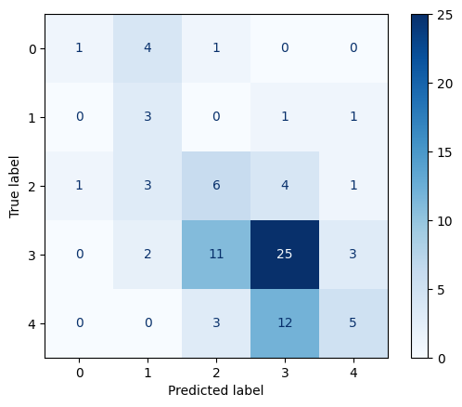
- Confusion Matrix: True vs Predicted Labels for MLR.
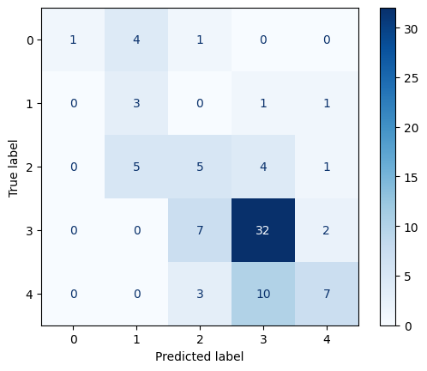
- Confusion Matrix: True vs Predicted Labels for RR.
- SVM
The SVM model achieves an accuracy of 62% with a cross-validation standard deviation of 4.6%, indicating stable and consistent performance across folds. Although prediction quality is uneven - favouring the dominant class 3 while underperforming on classes 1 and 2 - the model attains an MAE of 0.67, showing that predictions deviate by less than one severity level on average. Most errors occur between neighbouring classes, confirming that the model preserves the ordinal structure of severity despite reduced sensitivity to minority classes.
- Random Forest Tree
The Random Forest models were evaluated on an 80/20 stratified train-test split to preserve the severity distribution. A majority class baseline achieved 0.448 accuracy, indicating that simply predicting the most frequent severity level performs poorly for minority classes. A Random Forest using only structured features produced a small improvement, reaching 0.471 accuracy with a Macro F1 of 0.393, suggesting a limited predictive signal from weather and calendar variables alone.
Adding TF IDF text features produced a large performance gain. The combined text plus structured model achieved 0.759 accuracy with a Macro F1 of 0.677, showing that language patterns in the articles are the main driver of severity prediction. After hyperparameter tuning with stratified 5-fold cross-validation, the final tuned model achieved 0.862 accuracy and a Macro F1 of 0.859 on the held-out test set, indicating strong performance across classes rather than only on the dominant class.
Error analysis from the confusion matrix showed that most mistakes occur between adjacent severity levels, which is expected because neighbouring classes often share similar wording. Per class scores were generally strong, although severity class 2 was comparatively weaker before tuning, consistent with overlap in phrasing between moderate and higher severity reports. Feature importance also aligned with the task, with high ranking TF IDF terms such as hospital, injuries, death, and fatal, while structured variables such as tag indicators and selected weather features contributed a smaller supporting signal.

4. Comparative Analysis
This section compares the three techniques using a single shared evaluation protocol to ensure differences reflect model behaviour rather than data splitting choices. Severity labels are encoded from 0 to 4, where larger values represent increasing severity. All techniques were trained on the same frozen training rows and evaluated on the same frozen test rows, using the same target definition and metric set. Evidence is provided through the metrics table, confusion matrices, ROC analysis where continuous scores are available, interpretability outputs, and paired bootstrap significance testing.
4.1 Shared Evaluation Protocol:
A single stratified split was created once and reused for all techniques. Macro F1 is treated as the primary class-balanced metric because it weights each class equally and is therefore sensitive to minority class performance. Training time and prediction time were recorded under the same environment to support deployment-relevant trade-off discussion.

4.2 Comprehensive Metrics Comparison
The headline results show a clear ranking. Random Forest achieved the strongest overall performance, with Accuracy 0.7471, a macro F1 of 0.6774, a weighted F1 of 0.7115, and a macro ROC AUC of 0.9415. Ridge-based linear approach ranked second, with Accuracy 0.6667, Macro F1 0.5146, Weighted F1 0.6063, and Macro ROC AUC 0.8500. SVM performed weakest, with Accuracy 0.5287, a macro F1 of 0.3321, a weighted F1 of 0.4329, and a macro ROC AUC of 0.6606.
Efficiency results favour Ridge based linear approach. Ridge based linear approach was the fastest to train and predict at 0.0658 seconds and 0.0071 seconds. SVM was intermediate at 0.1303 seconds and 0.0208 seconds. Random Forest was the slowest at 0.2142 seconds and 0.0328 seconds. These absolute times are small for the current dataset, so predictive quality is likely to dominate the choice unless strict latency constraints apply.
Figure 13 summarises the headline performance and timing metrics for each technique on the shared test split, showing that Random Forest achieves the highest Accuracy 0.7471, Macro F1 0.6774, Weighted F1 0.7115, and Macro ROC AUC 0.9415, while Ridge based linear approach is the fastest to train 0.0658 seconds and predict 0.0071 seconds, and SVM performs weakest overall with the lowest Macro F1 0.3321 and Macro ROC AUC 0.6606.
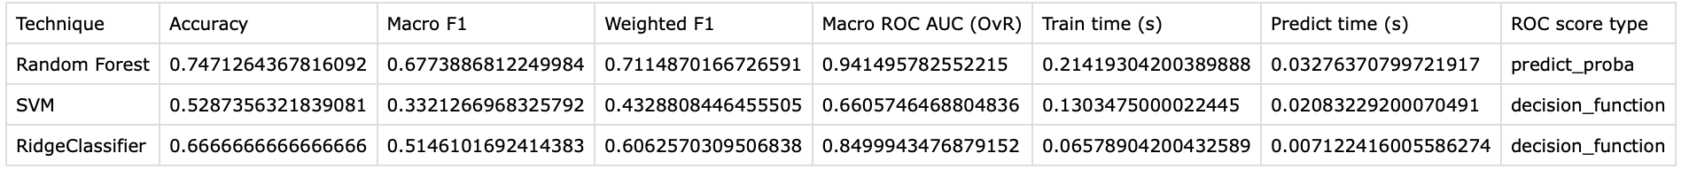
- Summary of performance
4.3 Confusion Matrix and Error Patterns:
Confusion matrices indicate that Random Forest produces the most balanced error profile across classes, with most error occurring between adjacent mid-severity classes rather than complete class collapse. Ridge based linear method improves materially over SVM but still shows weaker recognition for the minority class, which depresses Macro F1 despite a moderate Accuracy. This makes SVM difficult to justify where reliable coverage across severity levels is required.
Figure 14 compares the confusion matrices for all three techniques on the same test set and shows that Random Forest and Linear Regression produce more concentrated diagonal mass, while the SVM collapses many cases into the predicted class 3, leading to systematic misclassification of true classes 1, 2, and 4.
- Confusion Matrix
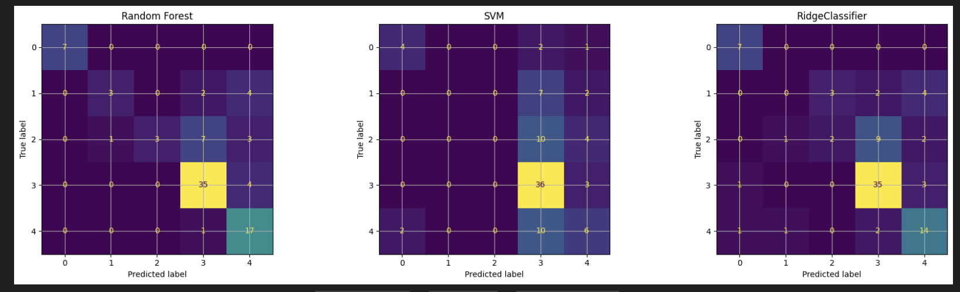

4.4 ROC Curves and Separability across thresholds:
ROC was computed using a one-versus-rest multiclass approach with macro-averaged AUC. Random Forest shows strong separability across classes and achieves the highest Macro ROC AUC 0.9415. Ridge based linear approach is second at 0.8500, while SVM is substantially lower at 0.6606, with notably weak per-class separability for some minority classes. Random Forest ROC uses predicted probabilities, whereas SVM and Ridge-based linear approach ROC use decision scores. In the latter case, ROC remains a valid ranking metric but should not be interpreted as a calibrated risk estimate without additional calibration.
Figure 15 shows the macro-averaged one-versus-rest ROC curves, where Random Forest achieves the strongest overall separability with a Macro ROC AUC of 0.941, the Ridge-based linear approach follows with 0.850, and SVM performs the weakest with 0.661, indicating that Random Forest provides the most reliable class ranking across thresholds on the shared test set.
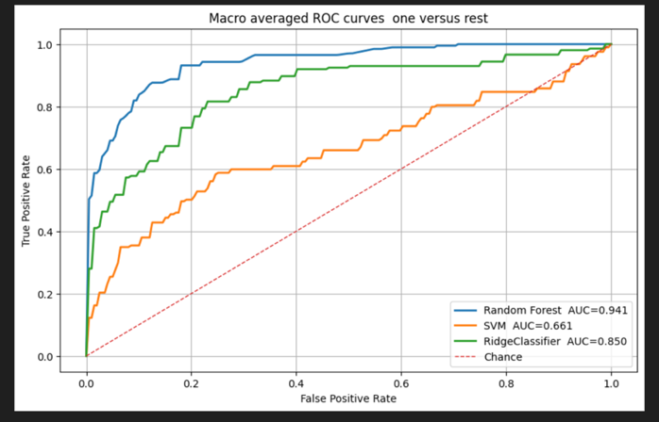
- Macro VS ROC Curve
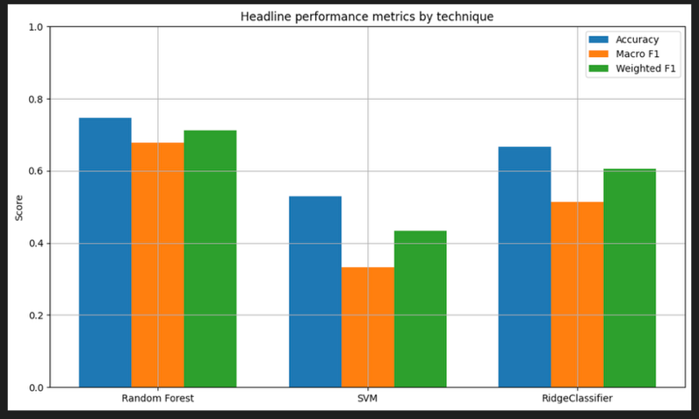
4.5 Interpretability Evidence and Limitations
Interpretability evidence differs by model family. Random Forest provides impurity-based feature importance, Ridge based linear approach provides coefficients, and SVM interpretability was supported using permutation importance because a nonlinear kernel does not yield a single global coefficient representation. Impurity-based feature importance can overstate the importance of noisy or high cardinality inputs, so Random Forest importance should be treated as indicative rather than causal. For the RBF SVM, permutation importance reflects sensitivity within the current test distribution and can be unstable with correlated TF IDF features, so it is best interpreted as a coarse diagnostic.

- Headline Metrics
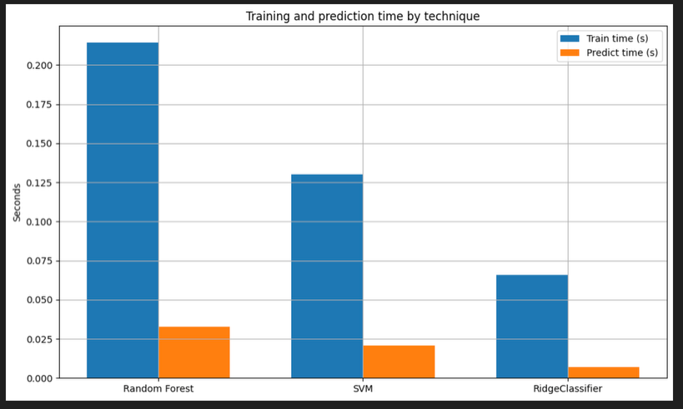
Figure 16 summarises the headline metrics and confirms the same ranking as Table 1, where Random Forest is highest on Accuracy, Macro F1, and Weighted F1, Ridge-based linear approach is consistently second, and SVM is lowest across all three measures.
- Training and Prediction by Technique
Figure 17 shows that Ridge based linear approach is the most efficient technique with the fastest training and prediction times, SVM is intermediate, and Random Forest is the slowest, although the absolute times remain small at this dataset scale, so performance differences are likely more important than latency.

4.6 Statistical Significance of Performance Gaps:
Paired bootstrap testing was used to assess whether Macro F1 differences are likely meaningful. Random Forest outperformed SVM with a mean Macro F1 difference of 0.3414 and a 95 percent confidence interval from 0.2038 to 0.4805. Random Forest also outperformed Ridge based linear approach with a mean difference of 0.1587 and a 95 percent confidence interval from 0.0397 to 0.2757. Ridge-based linear approach outperformed SVM, with Macro F1 higher by 0.1827 on average and a 95 percent confidence interval from 0.0761 to 0.2867. As these intervals do not cross zero, the ranking is supported for this evaluation.
Figure 118 shows that the Macro F1 differences are consistently away from zero, with Random Forest outperforming SVM by 0.3414 (95 percent CI 0.2038 to 0.4805) and Ridge based linear approach by 0.1587 (95 percent CI 0.0397 to 0.2757), while Ridge based linear approach also outperforms SVM because the SVM vs Ridge based linear approach difference is negative at minus 0.1827 (95 percent CI minus 0.2867 to minus 0.0761).

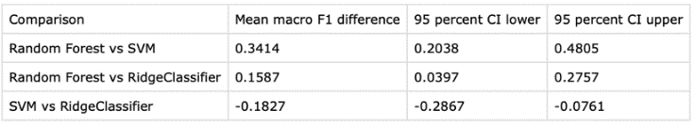
- Macro F1 comparisons

4.7 Trade-offs and Overall Comparison
Random Forest provides the best predictive quality and separability, at the cost of higher complexity and the slowest training and prediction times of the three. Ridge based linear approach offers the strongest transparency and speed, but with weaker minority-class coverage than Random Forest. SVM does not justify its complexity in this setting due to materially weaker balanced performance and minority class recognition.

- Key Insights
5.1 Overall Ranking and Robustness of Results:
Across the shared split evaluation, Random Forest emerges as the strongest overall technique, achieving the highest class-balanced performance and the best separability across thresholds. The paired bootstrap testing supports that the Macro F1 advantage of Random Forest over the other techniques is unlikely to be explained by random variation in the held-out test set, strengthening confidence in the observed ranking for this evaluation.

5.2 Practical Backup choice:
Ridge based linear approach is a credible secondary option. It clearly outperforms SVM while remaining the fastest approach for both training and inference, and it offers a more transparent explanation mechanism through coefficients. The trade-off is reduced Macro F1 relative to Random Forest, suggesting that minority severity classes are not captured as reliably under a linear decision boundary.
5.3 Error Patterns and Policy Relevance:
The dominant error pattern across techniques is confusion between adjacent severity levels, which is expected for ordered severity style labels. For deployment, this implies that error costs are not uniform. Misclassifying a genuinely high-severity case as a lower severity class is more harmful than over-escalating a borderline case, so thresholding and escalation rules should be designed with asymmetric costs in mind, potentially including human review for high-impact decisions.

5.4 Interpreting ROC Correctly:

ROC-based results are informative but require careful interpretation. Random Forest ROC is based on predicted probabilities, whereas Ridge based linear approach and SVM ROC are based on decision scores. ROC remains a valid ranking measure in both cases, but decision scores should not be treated as calibrated risk without additional calibration, especially if model outputs are used to justify policy actions or operational escalation.
5.5 Reproducibility Artefacts:
To support reproducibility and prevent manual transcription errors in the write-up, the comparative metrics table and the paired bootstrap significance results were exported directly from the notebook as metrics_comparison_table.csv and bootstrap_macro_f1_significance.csv. These files provide an auditable copy of the headline results used in the report.
Ethical Considerations
  - Bias/Fairness:
Fairness in this evaluation is therefore framed as performance consistency across conditions, rather than fairness across protected demographic groups, since demographic attributes are not present. Bias and fairness considerations are critical because the model outputs may influence operational decisions, resource allocation, or escalation workflows. In this setting, unfairness would most plausibly arise from unequal performance across subgroups, either because the input features act as proxies for protected characteristics or because the training data is imbalanced in ways that cause systematic underperformance for certain conditions.

1.2 Proxy Variables and Potential Source of Bias:

A common proxy risk in incident-style datasets is location, because geographic indicators can encode socioeconomic patterns, differences in reporting practices, or uneven policing and enforcement intensity. In the present dataset, no location-like column was detected, so a direct geographic proxy audit could not be performed. This reduces one obvious proxy risk, but it does not eliminate it entirely, as proxy effects can still occur through correlated signals in the text field or categorical tags.
Temporal proxy effects were assessed using the available time field. Grouped evaluation by month shows that performance varies across months. This can indicate temporal bias if model quality degrades during certain periods, but it must be interpreted cautiously because several month buckets contain small sample sizes. With small group sizes, apparent gaps may reflect sampling noise rather than a consistent bias pattern. Nevertheless, the presence of variability supports treating time as a potential fairness-relevant condition that should be monitored if the system is deployed.
1.3 Fairness across conditions and groups:
Fairness in this evaluation is therefore framed as performance consistency across conditions, rather than fairness across protected demographic groups, since demographic attributes are not present. The month-grouped results show that Random Forest generally maintains a higher Macro F1 than the other techniques across most buckets, but all techniques experience fluctuations. Where performance dips coincide with small sample sizes, the results should be treated as a warning signal rather than a definitive disparity. From a risk perspective, the key fairness concern is that reduced performance in particular time periods could lead to systematically poorer service outcomes for cases occurring in those periods, even if no explicit sensitive group variable exists.
2. Transparency
2.1 Model-level Transparency by technique:
Ridge based linear approach provides the clearest global interpretability because it is a linear model. Its coefficients can be inspected to understand which inputs most strongly influence the decision boundary, and whether they push predictions towards higher or lower severity. This makes it suitable when explanation and accountability are prioritised, even if absolute performance is lower than the best-performing model.

Random Forest is less transparent than Ridge based linear approach, but still offers useful interpretability evidence via feature importance rankings. These rankings summarise which features contribute most to impurity reduction across the ensemble and can highlight the dominant signals driving predictions. However, impurity-based feature importance can overstate the importance of noisy or high cardinality inputs, so the outputs should be treated as indicative patterns rather than causal explanations.
SVM with an RBF kernel is the least transparent in this comparison because it does not provide an interpretable set of global coefficients. For this reason, interpretability was supported using permutation importance, which estimates how sensitive model performance is to disruptions in each input feature. For non-linear models, this is a practical diagnostic, but it reflects the behaviour of the model within the current test distribution and can be unstable, particularly where TF IDF features are correlated. As a result, it should be interpreted as a coarse indicator rather than a definitive ranking.
2.2 Implications for use
Given the differences above, the transparency trade-off aligns with the performance trade-off. Random Forest provides the best predictive quality but requires more careful explanation and auditing, while Ridge based linear approach provides the most straightforward explanation mechanism but at lower class-balanced performance. For deployment, the choice should therefore reflect whether the primary requirement is maximum predictive performance or stronger interpretability and simpler governance.
3. Deployment Risks:
Deployment risks arise when model outputs are used in real workflows, where errors have unequal costs and where the model can influence the future data it is trained on. In this project, the key risks relate to false positives and false negatives, policy and operational impacts, temporal drift, and the possibility of feedback loops.
3.1 Policy impacts and Operational Behaviour:
If the model influences decisions, it can also influence reporting behaviour. Staff may adapt their tagging or language to trigger a particular prediction, or may rely on the tool in ways that reduce independent judgment. Over time, this can change the input distribution, particularly in the text vocabulary and tag frequencies, which can degrade model performance. These effects are especially important in datasets where the text field is a major predictor, as shifts in terminology can occur even without changes in the underlying phenomenon.

3.2 Feedback loops and dataset shift:
A common deployment failure mode is a feedback loop where model predictions affect which cases are investigated or recorded, which then changes the training data and reinforces the model’s existing biases. Even without explicit demographic features, this can lead to systematic over-emphasising of certain incident types or under detection of others. The temporally grouped results in Notebook 4 already show performance variability across months, which suggests that time related distribution shift is plausible. Without monitoring, a model that performs well on the current test set could drift and become unreliable in later periods.
3.3 Score Interpretation and Communication risk:
Another deployment risk is the misinterpretation of outputs. ROC analysis in Notebook 4 uses probabilities for Random Forest, but decision scores for SVM and Ridge-based linear approach. Decision scores support ranking but are not calibrated probabilities. If decision scores are communicated as risk percentages, users may place unjustified confidence in the outputs. If a calibrated probability is required, explicit calibration and validation would be needed before deployment.
4. Recommendations:
The comparative evaluation supports a clear technical recommendation, but safe use requires safeguards that reflect the asymmetric costs of severe errors and the potential for drift over time. The recommendations below combine model choice, workflow design, monitoring, and governance.
4.1 Recommended Techniques and Fallback
Random Forest is recommended as the primary technique because it achieves the strongest overall performance on the shared evaluation split, including the highest Macro F1 and Macro ROC AUC, and the paired bootstrap results support that its Macro F1 advantage is likely meaningful for this evaluation. Ridge based linear approach is recommended as a fallback because it is fast, more transparent through coefficients, and performs materially better than SVM on class-balanced metrics.
4.2 Human oversight and decision thresholds:
The model should be deployed as decision support rather than an automated decision maker. A practical safeguard is to require human review for the highest severity predictions and for cases where the model output indicates uncertainty, reducing the risk of harmful false negatives and over-reliance on the tool.

4. 3 Monitoring, drift detection, and retraining:
Monitoring should track Macro F1 and class-specific recall for higher severity classes over time, not only globally. As the time bucket analysis shows variability across months, drift checks should trigger when performance degrades across consecutive periods or when input distributions shift, such as changes in tag frequencies or text vocabulary. Retraining can be scheduled periodically, for example, quarterly, and brought forward if monitoring indicates sustained degradation.

4.4 Audit logging and documentation:
Predictions should be logged with model version, timestamp, input summary, predicted class, and score type used. Documentation should include training data scope, the shared evaluation protocol, headline metrics, and known limitations, such as small sample sizes in some time buckets, clarifying intended use boundaries.

4.5 Feature governance and proxy controls:
Although no explicit location field was present here, future dataset versions may introduce proxy-sensitive features such as location. If introduced, these should only be used after subgroup performance audits and governance approval, and models should be tested with and without such features to quantify both performance and fairness impacts.

4.6 Safe communication of scores:
Where probabilities are not calibrated, decision scores should be communicated as ranking signals rather than absolute risk estimates. If probability thresholding is required, probability calibration should be implemented and validated before deployment.

VI. Discussion
1.1 Summary:
This project evaluated three supervised learning techniques for multiclass severity prediction using a shared and frozen train-test split to ensure a fair comparison. Performance was assessed using a consistent set of metrics that capture both overall correctness and class-balanced behaviour, including Accuracy, Macro F1, Weighted F1, and multiclass one-versus-rest ROC AUC, where continuous scores were available. The comparative results show that Random Forest provides the strongest overall predictive performance and the best class separability, while Ridge based linear approach offers a competitive and more transparent alternative with the fastest training and inference. SVM underperformed on class-balanced measures, highlighting that moderate Accuracy alone is not sufficient evidence of reliable behaviour in an imbalanced multiclass setting. Statistical testing using paired bootstrap resampling supports that the observed Macro F1 differences are likely meaningful for this evaluation, strengthening confidence in the final model recommendation. Overall, the findings support using Random Forest as the primary approach for decision support, with Ridge based linear approach as a practical fallback when interpretability or computational simplicity is prioritised, provided that deployment includes human oversight and ongoing monitoring to manage risk.
1.2 Various ML Results:

The results show clear differences in how each model family handles the mixed text and structured inputs, and how well each technique performs across all severity classes. Random Forest achieved the strongest overall balance, with the best class-balanced performance and the highest ROC separability. Its confusion matrix indicates more reliable recognition of the dominant classes and fewer harmful misclassifications than the alternatives, although adjacent class confusion remains, which is expected in ordered severity labels. The feature importance outputs also suggest that both the text signal and selected structured indicators contribute meaningfully, supporting the value of the mixed feature representation.
Ridge based linear approach performed as a robust middle ground. It does not match RF on Macro F1, but it improves substantially over SVM while offering clear interpretability through coefficients and the fastest training and inference. This makes it attractive when explanations and operational simplicity are prioritised. The results suggest a linear boundary captures a large portion of the structure in the data, but is less flexible for minority class distinctions.
SVM with an RBF kernel produced the weakest class-balanced outcomes and shows difficulty with minority severity classes. Even though ROC can be computed using decision scores, overall separability is lower, and the confusion matrix indicates underdetection in some classes. Overall, the evidence supports RF as the primary choice, with Ridge based linear approach as the most practical alternative when transparency and speed matter most.
1.3 Limitations:
Several limitations should be considered when interpreting these results. First, the evaluation is based on a single frozen train test split. While this supports a fair comparison across techniques, it does not capture variability that may arise under different splits or resampling procedures. The paired bootstrap significance testing reduces this concern by estimating uncertainty on the held-out test set, but it does not replace a repeated cross-validation style analysis.
Second, the dataset shows class imbalance, and some classes have relatively small support in the test set. This makes Macro F1 an appropriate headline metric, but it also means that per-class performance estimates can be noisy, particularly for the least frequent classes. The grouped time bucket analysis illustrates a related issue, where month-level sample sizes are sometimes small, so apparent differences across months may reflect sampling noise rather than stable temporal effects.
Third, interpretability evidence is limited by the methods used. Random Forest impurity-based feature importance can overstate the importance of noisy or high cardinality inputs, so it should be treated as indicative rather than causal. Permutation importance for the RBF SVM reflects sensitivity within the current test distribution and can be unstable when features are correlated, especially with TF IDF style representations. As a result, interpretability outputs provide useful diagnostics, but they should not be overclaimed as definitive explanations.
Finally, the study is constrained by the available feature set. No explicit geographic or demographic attributes were present, so fairness analysis is limited to conditions such as time buckets rather than protected group comparisons. Any deployment in a richer data environment would require additional subgroup audits, calibration checks, and governance controls before model outputs could be used in policy-relevant workflows.
1.4 Future Work:
Future work should prioritise stronger generalisability and safer deployment readiness. A first improvement would be to repeat evaluation across multiple resamples, for example, repeated stratified splits or cross-validation, to quantify how stable the ranking is beyond a single split. Addressing class imbalance more directly may also improve minority class recall, using approaches such as class weighting, threshold tuning, or resampling, while keeping Macro F1 as a primary objective.
If probability-based decisions are required, calibration should be added and validated so that outputs can be interpreted as reliable risk estimates rather than only rankings. Feature development could also be expanded, for example, by testing richer text representations, refining engineered signals, and investigating whether additional context features improve separation between adjacent severity levels without introducing proxy bias.
From a governance perspective, future dataset versions should include structured fairness audits if geographic or other proxy-sensitive fields are introduced. A deployment-focused extension would implement a monitoring pipeline that tracks class-balanced metrics over time, detects drift in both inputs and performance, and triggers retraining when degradation is sustained. Finally, usability testing with stakeholders would help define appropriate human review thresholds and escalation rules that reflect real-world error costs.
Conclusion
1.1 Key Takeaways:
The comparative results support Random Forest as the strongest overall approach for this dataset and task. It achieved the best class-balanced performance and the highest separability, indicating a stronger ability to distinguish severity levels across decision thresholds. The confusion matrix evidence further suggests that Random Forest makes fewer problematic misclassifications relative to the alternatives, even though some adjacent class confusion remains, which is expected when labels represent ordered levels of severity. Ridge based linear approach emerged as a defensible second choice. While it does not match Random Forest on Macro F1, it performs substantially better than the evaluated SVM configuration and provides clearer transparency through coefficients, alongside the fastest training and inference times. This makes Ridge based linear approach particularly attractive when interpretability and operational simplicity are prioritised. The SVM with an RBF kernel underperformed on class-balanced metrics and showed weaker minority class behaviour, indicating that it is not the most appropriate option under the current feature representation and evaluation objective. Overall, the findings reinforce that Accuracy alone is not sufficient in an imbalanced multiclass setting, and that Macro F1, per-class inspection, and error pattern analysis are essential for a reliable comparison.
1.2 Implications:
From a deployment perspective, the results imply that the recommended model should be used as decision support rather than an automated decision maker. Severity prediction carries asymmetric costs, where under-prediction of higher severity can be more harmful than over-prediction, so the workflow should include human review for high-impact cases and for outputs that indicate uncertainty. Monitoring is also essential because performance can vary across time buckets and input distributions can change, particularly in text-driven systems where vocabulary and tagging practices evolve. A practical deployment plan would therefore include drift checks, periodic retraining, and clear audit logging of model version, timestamp, predicted class, and score type used. Governance should remain cautious about introducing proxy-sensitive features, such as location in future dataset versions, requiring subgroup audits and impact assessment before they influence predictions. With these safeguards in place, the project’s comparative evidence supports a realistic and defensible recommendation: use Random Forest when maximising predictive quality is the priority, and keep Ridge based linear approach as a transparent and efficient fallback when explanation and operational constraints dominate.

REFERENCES
[1] J. Zhang and Y. Yang, “Robustness of regularized linear classification methods in text categorization,” in Proceedings of the 26th Annual International ACM SIGIR Conference on Research and Development in Information Retrieval (SIGIR ’03), Toronto, Canada, 2003, pp. 190–197, doi: 10.1145/860435.860471.

[2] N. A. Azeez, S. Misra, D. O. Ogaraku, and A. P. Abidoye, “A predictive model for benchmarking the performance of algorithms for fake and counterfeit news classification in global networks,” Sensors, vol. 24, no. 17, Art. no. 5817, 2024, doi: 10.3390/s24175817.

[3] D. S. Ramdan, R. D. Apnena, and C. A. Sugianto, "Film Review Sentiment Analysis: Comparison of Logistic Regression and Support Vector Classification Performance Based on TF-IDF," Journal of Applied Intelligent System, vol. 8, no. 3, pp. 341–352, Nov. 2023.

[4] Imamah and F. H. Rachman, "Twitter Sentiment Analysis of Covid-19 Using Term Weighting TF-IDF And Logistic Regresion," in 2020 Information Technology International Seminar (ITIS), Surabaya, Indonesia, 2020, pp. 238-242.

[5] L. L. Johnson, C. B. Borkowf, and P. A. Shaw, “Hypothesis testing,” in Principles and Practice of Clinical Research, 4th ed., J. I. Gallin, F. P. Ognibene, and L. L. Johnson, Eds. Boston, MA, USA: Academic Press, 2018, pp. 341–357, doi: 10.1016/B978-0-12-849905-4.00024-1.

[6] Scikit-learn, “Support Vector Machines,” Scikit-learn Documentation. [Online]. Available: https://scikit-learn.org/stable/modules/svm.html

[7] M. Abdel-Aty, “Using support vector machine models for crash injury severity analysis,” Accident Analysis & Prevention, vol. 45, pp. 478–486, Mar. 2012, doi: 10.1016/j.aap.2011.08.016

[8] L. Breiman, “Random forests,” *Machine Learning*, vol. 45, no. 1, pp. 5–32, 2001.

[9] M. Sokolova and G. Lapalme, “A systematic analysis of performance measures for classification tasks,” *Information Processing and Management*, vol. 45, no. 4, pp. 427–437, 2009.

[10] R. Kohavi, “A study of cross validation and bootstrap for accuracy estimation and model selection,” in *Proc. 14th Int. Joint Conf. Artificial Intelligence (IJCAI)*, 1995, pp. 1137–1143.

[11] D. Sarkar, "Understanding Feature Engineering (Part 3) — Traditional Methods for Text Data," Towards Data Science, Jan. 29, 2018

